**UNIT 1**

**Lesson 3 - Job applications**

**apply for a job**

**resumé = CV**

1. **Look at Jiaming Chen´s CV[1] and indicate what information it includes.**

|  |
| --- |
| name – education (university/location) – skills – work experience – projects – organizations – contact information – social media |

1. **Now read Chen´s CV and answer. 22/04**
2. Has she finished her studies? How do you know? No, she hasn´t because she wrote the expected graduation date.
3. What languages does she speak? She speaks Spanish, English and Mandarin.
4. What programming languages can she use? She can use Python, Java, NodeJS, ReactJS, and C++.
5. What did she do from June 2021 to September 2021? She was a DevOps. She developed foundation in Java to create … / She worked as a Software Engineering Intern at Oracle Cloud Infrastructure (EADevOps)
6. What did she do from June 2022 to September 2022? She was an intern at Compute Imaging DP at Oracle; she used Swagger to create an API Client and redesigned the Agent Admin tool with ReactJS.
7. How many projects did she work on? Can you describe them? She worked on 2 projects.

Temperature Regulated Pet House: She cooled pet enclosures using an automated system and C++ code for Arduino.  
  
Battleship: She recreated the game to demonstrate inheritance and polymorphism concepts, using the Linux terminal.

1. What´s her job now? What does she do? Currently, she **is** a Student Ambassador for Leadership in Engineering Advancement Diversity and Retention (LEADR) at UC Davis. She **mentors** underrepresented freshman engineering majors to help them transition to university life.  
   She **provides** programming tutoring for 1st and 2nd-year students to strengthen their foundational concepts.

Happy Face Emoticon Stock Illustrations – 154,845 Happy Face Emoticon Stock  Illustrations, Vectors & Clipart - Dreamstime **Designing your CV - 29/04 - In class**

These are some useful phrases that you can use when writing about your skills.

* **Skilled in** Linux Operating Systems.
* **Proficient in** ReactJS for Front-end and NodeJS for Back-end.
* **Advanced proficiency in** Chart.js. HTML and CSS.
* **Fluent in** English and Portuguese.
* A computer science student who **excels at** Java and Python.
* **Highly** **adept at** creating a positive work atmosphere.

1. **Can you complete these about you?**
   1. **Skilled in** … c++ / Java
   2. **Proficient in** … Object Oriented Programming (OOP)
   3. **Advanced proficiency in** … databases – data systems – Testing QA – Mobile Development
   4. **Fluent in** … Italian – German – French - Chinese
   5. A programming student who **excels at** … front end / back end (NestJs and Microservices)
   6. **Highly** **adept at** … teamwork – leadership – communication – productive – proactive - Problem-Solver

Happy Face Emoticon Stock Illustrations – 154,845 Happy Face Emoticon Stock  Illustrations, Vectors & Clipart - Dreamstime **You should also consider these items, when you write about your work experience.**

* Describe your work experience and projects and keep it concise.
* List your experience in reverse chronological order (the most recent job at the top). You can include internships, part-time jobs, and other relevant experiences.
* First, write the internship or job and clearly state your role and the company name and location, then, show the period you worked there, and, finally, your responsibilities.
* Use bullets to list your responsibilities and do not write a pronoun before the verbs in the **past tense**.

 **Remember!**

The **Simple Past tense** is used to describe actions and events that happened at a specific time in the past. You can use **a regular or an irregular verb** **in the past**.

1. **You can use some of these verbs in the past tense when you describe your experience. Can you think of others?**

**designed – redesigned – built – developed – created - recreated – incorporated debugged – presented - formulated – reformulated – utilized - …managed - called – talked – organized – maintained – corroborated – analysed – engaged – enhanced - supervised**

1. **Write about your Work experience and Projects using some of the verbs in the box in Activity 4.**

**Work experience**

… (internship, part-time job, full-time job) – … (company) - from … to …

**Software Developer, full-time job – Accenture - from March 2023 to January 2025**

- Developed REST APIs using Spring Boot

- Debugged and fixed bugs and issues

- Utilized Linux and Windows OS’s

**Maintenance manager, full time job, Multicapotas SRL, January 2016 to the Present**   
· Design and create mechanical pieces for Production Machinery.  
· Utilize AutoCAD, Optitex, Mach3, and Vcarve software to design and cut pieces.  
· Maintain machinery.  
· Create reports about machinery status.  
· Implement ISO and IATF norms

Happy Face Emoticon Stock Illustrations – 154,845 Happy Face Emoticon Stock  Illustrations, Vectors & Clipart - Dreamstime **What about your present internship, part-time or full-time job?**

* First, write the internship or job title and clearly state your role and the company name and location, then, show the period you have worked there, and, finally, your responsibilities.
* Use bullets to list your responsibilities and do not write a pronoun before the verbs in the **present tense**.

**Organization**

………. (internship, part-time job, full-time job) - … (company) - from … to present

- …………………………………………………………….

- …………………………………………………………….

- …………………………………………………………….

**Pay attention to this!**

**What is the 7 second rule for CV?[2]**

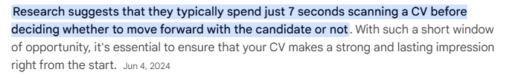

1. **Read this webpage** <https://simple.wikipedia.org/wiki/Steve_Wozniak>  **about Steve Wozniak (Jobs´s partner) and write his CV with the information in it.**

… (internship, part-time job, full-time job) – … (company) - from … to …

**Co-founder. Computer Programmer - Apple Inc Full-time job** **- From 1977 to 1985**  
· Co-founded the company with Steve Jobs

* Designed and built the Apple I, II and III computers

1. **Watch this video about Wozniak and put the sentences in chronological order.** <https://drive.google.com/file/d/1N7EWbYXuKSdgJBwhawHn3igv8Ri5egcf/view?usp=drivesdk>

**2 -** Wozniak saw the first MITS´ Altair at the hobbyist club.

**5 -** The first computer was named the Apple I.

**6 -** Jobs, Wozniak and Wayne founded Apple Computer in Jobs´s garage.

**4 -** Wozniak produced the first computer with a typewriter-like keyboard.

**1 -** Wozniak and Jobs attended the Homebrew Computer Club, a computer hobbyist group.

**3 -** MITS´ build-it-yourself kit inspired Wozniak.

1. **Harish Kumar in LinkedIn suggests that you should always send your CV with a proper email. This is an example.**

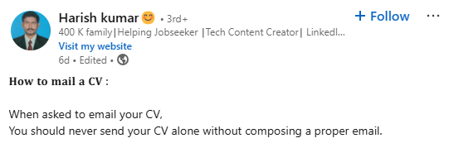

1.  **Choose a proper template, write your CV and upload it to the Moodle room.**

06/05

1. **When you apply for a job and send your CV, the HR Manager generally calls you for an interview. Claus Villumsen[3] suggests considering some useful questions for interviews. Can you make a list of those questions?**

……………………………………………………………………………………………………………………………………………………………………………………………………………………………………………………………………………………

1. **Pair work - A job interview**

One of you is the HR Manager and the other is the applicant for the job. Complete the Projects column and then, roleplay the situation with the information in the grid to.

|  |  |  |  |  |
| --- | --- | --- | --- | --- |
| **Job title** | **The manager** | **The culture** | **The work** | **Projects** |
| Data scientist | He/she lacks empathy. | Employees feel disrespected. | Employees can´t  develop their  skills. |  |
| Mobile app developer | He/she fails to  communicate clearly. | Information isn´t  shared openly. | There´s little  flexibility. |  |
| IT Technician | He/she doesn´t listen to  team members´ ideas. | There´s bullying and favouritism. | The work is  boring. |  |
| Cybersecurity software  developer | He/she participates in  gossip. | There´s lack of  diversity, equity and inclusion. | Employees can´t  make decisions or  work independently. |  |
| Trainee  Developer | He/she doesn´t take responsibility for mistakes. | Employees focus on individual goals. | It´s difficult to  meet deadlines. |  |
| Junior  developer | He/she doesn´t delegate  tasks effectively. | Employees feel overworked  and stressed. | The working  conditions are  not safe. |  |

1. **Can think of other useful questions for an interview?**

…………………………………………………………………………………………………………………………………………………………………………………………………………………………………………………………………………………………………………………………………………………………

1. **Pair work – Roleplay**

Imagine a real situation in which one of you is applying for a remote Web Developer Internship[4]. The other is the HR Manager. Roleplay the situation and then, change roles.

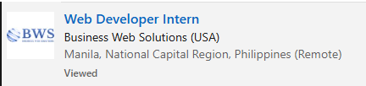

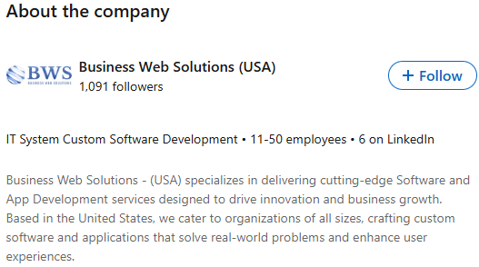

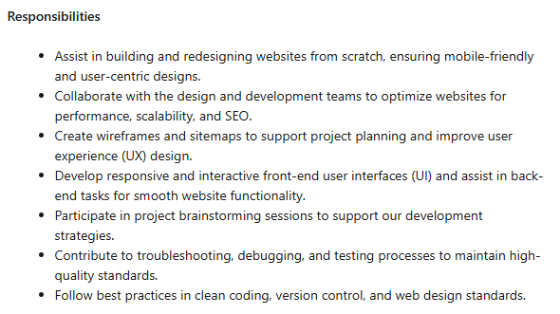

1. Source: <https://careercenter.ucdavis.edu/resumes-and-materials/resumes/resume-cv-samples>
2. Source: <https://www.google.com/search?q=what+to+include+in+your+cv&rlz>
3. Source: <https://www.linkedin.com/feed/update/urn:li:activity>
4. Source: <https://www.linkedin.com/jobs/search/?currentJobId=4202138459&keywords=web%20developer&location=worldwide>